Database Schema Documentation
Louisville Waterways Fishing Recommendation Data Warehouse
This database stores environmental, hydrological, and geographic data used to generate fishing safety and activity recommendations for Louisville-area waterways. Weather and river-flood forecasts are pulled from the Open-Meteo API for six fishing locations and loaded into a PostgreSQL database hosted in Supabase.
The schema is normalized to approximately Third Normal Form (3NF) by:
- separating fishing locations into a dimension table
- isolating weather observations from river-flood observations
- storing standardized WMO weather codes in a lookup table
- using a central fact table for computed fishing recommendations
- avoiding redundant environmental or geographic attributes

ER Diagram

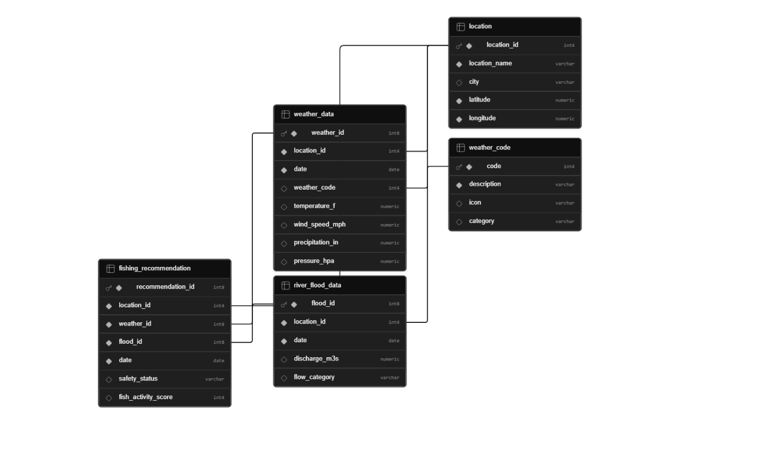

Database Overview
The database contains five tables:
- weather_code
- location
- weather_data
- river_flood_data
- fishing_recommendation

Entity Relationship Summary
Table | Purpose
weather_code | Stores standardized WMO weather condition codes, descriptions, icons, and category groupings
location | Stores fishing access points (parks, dams, ramps, lakes) with GPS coordinates
weather_data | Stores daily aggregated weather conditions per fishing location
river_flood_data | Stores daily river discharge and derived flow category per location
fishing_recommendation | Fact table combining all inputs to compute fishing safety status and activity score

Table Documentation

1. weather_code
Purpose
Stores standardized WMO (World Meteorological Organization) weather interpretation codes, their human-readable descriptions, display icons, and category groupings used to classify daily weather conditions.
Example
- Code 0 = Clear sky (Clear)
- Code 61 = Slight rain (Rain)
- Code 95 = Thunderstorm (Storm)
Primary Key
- code
Relationships
- One weather_code can relate to many weather_data records.
- Referenced by weather_data.weather_code.
Table Structure
Column Name | Data Type | Key | Description
code | INTEGER | Primary Key | Unique WMO weather condition code
description | VARCHAR(100) | Not Null | Human-readable description of the condition
icon | VARCHAR(10) |  | Emoji or symbol used in the UI
category | VARCHAR(30) |  | Category grouping (Clear, Cloudy, Rain, Snow, Fog, Storm)

2. location
Purpose
Stores the six Louisville-area fishing locations with their GPS coordinates. Acts as the central dimension table that every observation and recommendation references.
Example locations
- McAlpine Locks & Dam, Louisville
- Cox Park Boat Ramp, Louisville
- Taylorsville Lake, Taylorsville
- Otter Creek Outdoor Recreation, Brandenburg
Primary Key
- location_id
Relationships
- One location → many weather_data records
- One location → many river_flood_data records
- One location → many fishing_recommendation records
Table Structure
Column Name | Data Type | Key | Description
location_id | INTEGER | Primary Key | Unique location identifier
location_name | VARCHAR(120) | Not Null | Name of the fishing site
city | VARCHAR(80) |  | City the location is in
latitude | DECIMAL(9,6) | Not Null | GPS latitude
longitude | DECIMAL(9,6) | Not Null | GPS longitude

3. weather_data
Purpose
Stores daily aggregated weather conditions from the Open-Meteo API for each fishing location. Hourly observations are rolled up to daily values: temperature and pressure use the mean, wind uses the daily maximum (worst case for safety classification), and precipitation is summed across the day.
Primary Key
- weather_id (BIGSERIAL, auto-generated)
Foreign Keys
- location_id → location.location_id
- weather_code → weather_code.code
Constraints
- UNIQUE (location_id, date) — one weather row per location per day
- location_id and date are NOT NULL
Relationships
- Many weather records belong to one location
- Many weather records can share one weather_code
- Referenced by fishing_recommendation.weather_id
Table Structure
Column Name | Data Type | Key | Description
weather_id | BIGSERIAL | Primary Key | Auto-generated weather record ID
location_id | INTEGER | Foreign Key, Not Null | Linked fishing location
date | DATE | Not Null | Observation date
weather_code | INTEGER | Foreign Key | WMO condition code for the day
temperature_f | DECIMAL(5,2) |  | Mean daily air temperature in °F
wind_speed_mph | DECIMAL(5,2) |  | Max daily wind speed in mph
precipitation_in | DECIMAL(4,2) |  | Total daily precipitation in inches
pressure_hpa | DECIMAL(6,2) |  | Mean daily atmospheric pressure in hPa

4. river_flood_data
Purpose
Stores daily river discharge forecasts from the Open-Meteo Flood API (GloFAS model) and the derived flow category used by the safety classifier.
Primary Key
- flood_id (BIGSERIAL, auto-generated)
Foreign Keys
- location_id → location.location_id
Constraints
- UNIQUE (location_id, date) — one flood row per location per day
- location_id and date are NOT NULL
Derived Column
flow_category is computed in the load script from discharge_m3s:
- Low: discharge < 100 m³/s
- Normal: 100 – 1500 m³/s
- High: > 1500 m³/s
- Unknown: discharge is missing
Relationships
- Many flood records belong to one location
- Referenced by fishing_recommendation.flood_id
Table Structure
Column Name | Data Type | Key | Description
flood_id | BIGSERIAL | Primary Key | Auto-generated flood record ID
location_id | INTEGER | Foreign Key, Not Null | Linked fishing location
date | DATE | Not Null | Measurement date
discharge_m3s | DECIMAL(10,2) |  | Daily river flow rate in m³/s
flow_category | VARCHAR(30) |  | Derived bucket: Low / Normal / High / Unknown

5. fishing_recommendation
Purpose
Central fact table that joins one weather observation with one flood observation (per location per date) and stores the two derived outputs: safety_status and fish_activity_score. This is the table consumed by downstream dashboards and recommendation queries.
Primary Key
- recommendation_id (BIGSERIAL, auto-generated)
Foreign Keys
- location_id → location.location_id
- weather_id → weather_data.weather_id
- flood_id → river_flood_data.flood_id
Constraints
- UNIQUE (location_id, date) — one recommendation per location per day
- location_id, weather_id, flood_id, and date are NOT NULL
Relationships
- Each recommendation is generated from exactly one weather + flood pair
- Many recommendations can exist per location over time
Table Structure
Column Name | Data Type | Key | Description
recommendation_id | BIGSERIAL | Primary Key | Auto-generated recommendation ID
location_id | INTEGER | Foreign Key, Not Null | Fishing location
weather_id | BIGINT | Foreign Key, Not Null | Weather input reference
flood_id | BIGINT | Foreign Key, Not Null | Flood input reference
date | DATE | Not Null | Evaluation date
safety_status | VARCHAR(20) |  | Derived: Safe / Caution / Unsafe
fish_activity_score | INTEGER |  | Derived 0–100 score for fishing suitability

Cardinality Relationships
Parent Table | Child Table | Relationship Type
weather_code | weather_data | One-to-Many
location | weather_data | One-to-Many
location | river_flood_data | One-to-Many
location | fishing_recommendation | One-to-Many
weather_data | fishing_recommendation | One-to-Many
river_flood_data | fishing_recommendation | One-to-Many

Normalization Notes (3NF)
This schema is normalized to approximately Third Normal Form:
- Location attributes are stored once in the location dimension table.
- Weather condition descriptions are factored out into the weather_code lookup table.
- Weather and flood observations are separated by domain rather than denormalized into a single observation table.
- The fishing_recommendation fact table stores only derived outputs and foreign keys.
- Non-key columns depend only on each table's primary key.
- No repeating groups or multi-valued attributes exist in any base table.

Data Sources

Weather Data Source
Weather forecast data is sourced from the Open-Meteo Forecast API. The API provides:
- hourly temperature, precipitation, wind speed, and atmospheric pressure
- daily WMO weather interpretation codes
- 7-day forecast horizon
Hourly observations are aggregated to daily granularity inside the extract script before being loaded into weather_data.

River Flood Data Source
River discharge forecasts are sourced from the Open-Meteo Flood API (GloFAS hydrological model). The API provides:
- daily mean river discharge in m³/s
- 7-day forecast horizon

Location Data Source
The six fishing locations are seeded as hardcoded reference data in both the extract and load scripts. They represent established Louisville-area fishing access points (parks, dams, boat ramps, and lakes).

Scoring Logic (ETL Layer Reference)
The two derived columns in fishing_recommendation are computed in the load script and are documented here for reference.

Fish Activity Score (0–100)
Sum of four contributions, clamped at zero on the low end. Each band below maps to a fixed point value.
Factor | High points | Mid points | Low points / Penalty
Temperature (°F) | 30 if 60–80 | 15 if 50–60 or 80–90 | 5 otherwise
Wind (mph) | 20 if < 10 | 10 if 10–20 | 0 if ≥ 20
River flow (m³/s) | 30 if 200–1500 | 15 if 50–200 or 1500–2500 | 0 otherwise
Rain penalty (in) | 0 if ≤ 0.5 | — | −20 if > 0.5

Safety Status
- Unsafe — if wind > 25 mph OR river discharge > 3000 m³/s
- Caution — else if precipitation > 0.7 in
- Safe — otherwise

Example Relationship Flow
A single recommendation row for McAlpine Locks & Dam on a sunny, calm summer day pulls data from four other tables:
- location.location_id = 1 → McAlpine Locks & Dam
- weather_data.weather_id = 17 → 72°F, 6 mph wind, 0.0 in rain, weather_code = 0
- weather_code.code = 0 → "Clear sky" (category: Clear)
- river_flood_data.flood_id = 17 → 850 m³/s, flow_category = Normal
- fishing_recommendation row → safety_status = Safe, fish_activity_score = 80
The normalized design means the textual weather description ("Clear sky") is stored exactly once in weather_code, the location name is stored exactly once in location, and the fact table holds only the derived outputs and the foreign keys needed to reconstruct the full record.

